有的网页必须登陆才能看到，这个时候想要抓取信息必须在header里面传递cookie值才能获取

1、首先登陆网站，打开firebug就能看到对应的cookie把这些cookie拷贝出来就能使用了

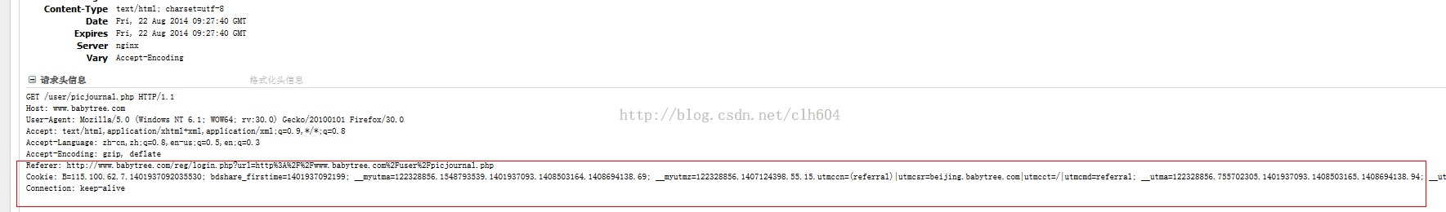

2、

<?php

header("Content-type:text/html;Charset=utf8");

$ch =curl_init();

curl_setopt($ch,CURLOPT_URL,'http://www.babytree.com/user/picjournal.php');

$header = array();

//curl_setopt($ch,CURLOPT_POST,true);

//curl_setopt($ch, CURLOPT_POSTFIELDS, $fields);

curl_setopt($ch,CURLOPT_RETURNTRANSFER,true);

curl_setopt($ch,CURLOPT_HEADER,true);

curl_setopt($ch,CURLOPT_HTTPHEADER,$header);

curl_setopt($ch,CURLOPT_COOKIE,'B=115.100.62.7.1401937092035530; bdshare_firstime=1401937092199; __myutma=122328856.1548793539.1401937093.1408503164.1408694138.69;');

$content = curl_exec($ch);

echo "<pre>";print_r(curl_error($ch));echo "</pre>";

echo "<pre>";print_r(curl_getinfo($ch));echo "</pre>";

echo "<pre>";print_r($header);echo "</pre>";

echo "</br>",$content;